Question 1

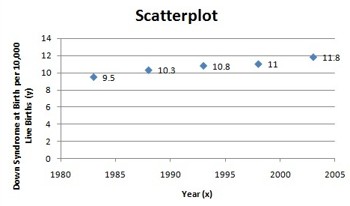
m = 0.106
b = -200.578
Trendline is: y=0.106*x-200.578
- What does this model give as the 2016 rate of Down syndrome births per 10,000 live births?
To answer this question simply put x=2016 in the equation of obtained trendline.
y=0.106*(2016)-200.578 = 13.118
y=13.1
Therefore, For every 10,000 live births in 2016, 13.1 babies were born with Down syndrome.
- Firstly, observe the "Fitted values of y i..e. yihat" which appear close to actual values of y.
- Secondly, Rsquared (Coefficient of Determination) value is 0.97 which is very close to 1. This means that 97% of the variation in the linear model is explained by the regressor. Thus, the model provides good fit. [Larger the value of Rsquare, better is the model.]
Yes, the linear model accurately represents the growth in babies born with Down syndrome until 2016.
Question 2
- Y=1.47x-21.35
- X=84 1.47x84-21.35 =102.13
- Yes, the linear model accurately indicates the increase in near point based on age.
Question 3

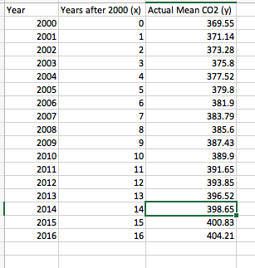

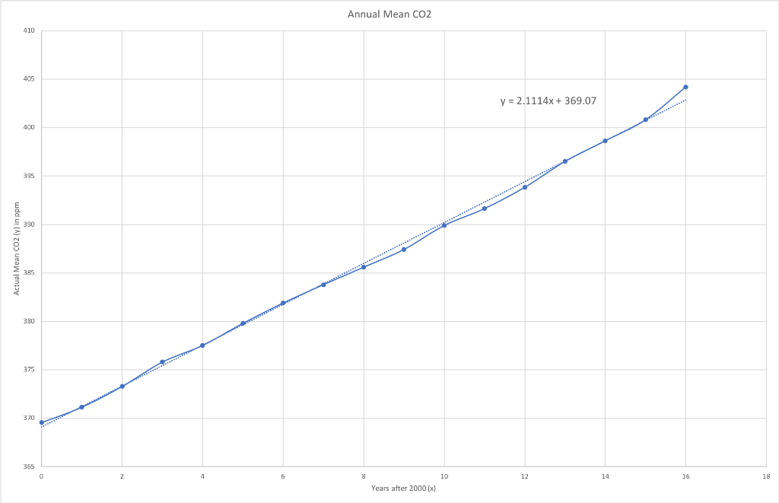

Y=2.1x+269.1
- Input =x= years
Output=y=actual mean of CO₂ in ppm
- Here slope = 2.1, means annual mean co₂ is increasing by 2.1 ppm years.
- Given year= 2050
Years after 2000=2050-2000=50
Y=2.1*50+369.1 = 474.1 ppm
Question 4
- Y=18.2x+84.627
- The only issue I found with this data is when we predict values for larger x we get y value far from the real value.
for example, at x =2 we get y=121.027 which is close to the original value 122.
when x = 11 we get y=284.827 which is far away from original value 264.3
therefore, the data is not reliable for larger x values that is we cannot predict usage of mobile phones for years far away from 2010.
Question 5
- Decrease in organic reduced fat milk is due it present of higher calories which is nit health for consumption.

